NAME:S.ROHINI
REG.NO:192424413
DATE:17-12-2025
DAY 2
LAB EXPERIMENTS
EXP.NO-6
Scenario: You are a cashier at a grocery store and need to calculate the total cost of a customer's purchase, including applicable discounts and taxes. You have the item prices and quantities in separate lists, and the discount and tax rates are given as percentages. Your task is to calculate the total cost for the customer.
Question: Use arithmetic operations to calculate the total cost of a customer's purchase, including discounts and taxes, given the item prices, quantities, discount rate, and tax rate?
CODE:
import numpy as np
data = np.loadtxt(
'grocery_purchase_data.csv',
delimiter=',',
skiprows=1,
usecols=(1, 2)
)
prices = data[:, 0]
quantities = data[:, 1]
discount_rate = 10
tax_rate = 5
subtotal = np.sum(prices * quantities)
discount_amount = (discount_rate / 100) * subtotal
price_after_discount = subtotal - discount_amount
tax_amount = (tax_rate / 100) * price_after_discount
total_cost = price_after_discount + tax_amount
print("Subtotal:", subtotal)
print("Discount Amount:", discount_amount)
print("Tax Amount:", tax_amount)
print("Total Cost to Pay:", total_cost)
OUTPUT:
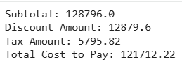
EXP.NO-7
Scenario: You are working as a data analyst for an e-commerce company. You have been given a dataset containing information about customer orders, stored in a Pandas DataFrame named order_data. The DataFrame has columns for customer ID, order date, product name, and order quantity. Your task is to analyze the data and answer specific questions about the orders.
Question: Using Pandas DataFrame operations, how would you find the following information from the order_data DataFrame:
1. The total number of orders made by each customer.
2. The average order quantity for each product.
3. The earliest and latest order dates in the dataset.
CODE:
import pandas as pd
# Load CSV file into DataFrame
order_data = pd.read_csv("order_data_big.csv")
# (Safety step) Convert all column names to lowercase
order_data.columns = order_data.columns.str.lower()
# Convert order_date to datetime
order_data["order_date"] = pd.to_datetime(order_data["order_date"])
# 1. Total number of orders made by each customer
orders_per_customer = order_data.groupby("customer_id").size()
# 2. Average order quantity for each product
avg_quantity_per_product = order_data.groupby("product_name")["quantity"].mean()
# 3. Earliest and latest order dates
earliest_order = order_data["order_date"].min()
latest_order = order_data["order_date"].max()
# Print outputs
print("Total number of orders made by each customer:")
print(orders_per_customer)
print("\nAverage order quantity for each product:")
print(avg_quantity_per_product)
print("\nEarliest order date:", earliest_order)
print("Latest order date:", latest_order)
OUTPUT:
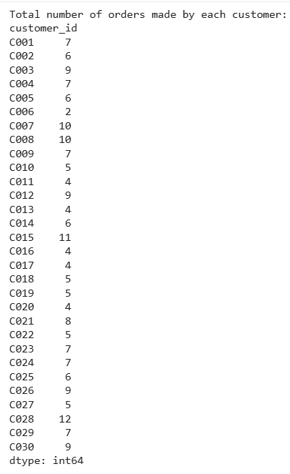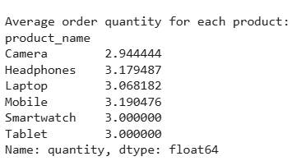

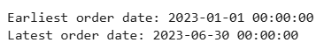

EXP.NO-8
Scenario: You are a data scientist working for a company that sells products online. You have been tasked with analyzing the sales data for the past month. The data is stored in a Pandas data frame.
Question: How would you find the top 5 products that have been sold the most in the past month?
CODE:
import pandas as pd
# Load the CSV file
sales_data = pd.read_csv("monthly_sales_big.csv")
# (Safety) Convert column names to lowercase
sales_data.columns = sales_data.columns.str.lower()
# Convert order_date column to datetime
sales_data["order_date"] = pd.to_datetime(sales_data["order_date"])
# Group by product and calculate total quantity sold
total_sales_per_product = (
sales_data.groupby("product_name")["quantity_sold"]
.sum()
)
# Sort products by total quantity sold in descending order
top_5_products = total_sales_per_product.sort_values(ascending=False).head(5)
# Display result
print("Top 5 products sold the most in the past month:")
print(top_5_products)
OUTPUT:
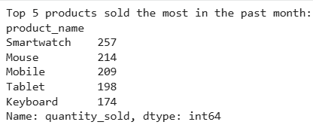

EXP.NO-9
Scenario: You work for a real estate agency and have been given a dataset containing information about properties for sale. The dataset is stored in a Pandas DataFrame named property_data. The DataFrame has columns for property ID, location, number of bedrooms, area in square feet, and listing price. Your task is to analyze the data and answer specific questions about the properties.
Question: Using Pandas DataFrame operations, how would you find the following information from the property_data DataFrame:
1. The average listing price of properties in each location.
2. The number of properties with more than four bedrooms.
3. The property with the largest area.
CODE:
import pandas as pd
# Load CSV file
property_data = pd.read_csv("property_data_big.csv")
# (Safety step) Convert column names to lowercase
property_data.columns = property_data.columns.str.lower()
# 1. Average listing price of properties in each location
avg_price_per_location = property_data.groupby("location")["listing_price"].mean()
# 2. Number of properties with more than four bedrooms
properties_more_than_4_bedrooms = property_data[property_data["bedrooms"] > 4].shape[0]
# 3. Property with the largest area
largest_area_property = property_data.loc[property_data["area_sqft"].idxmax()]
# Print results
print("Average listing price of properties in each location:")
print(avg_price_per_location)
print("\nNumber of properties with more than 4 bedrooms:")
print(properties_more_than_4_bedrooms)
print("\nProperty with the largest area:")
print(largest_area_property)
OUTPUT:
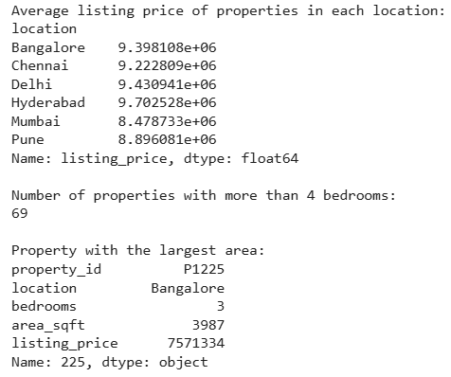
EXP.NO-10
Scenario: You are working on a data visualization project and need to create basic plots using Matplotlib. You have a dataset containing the monthly sales data for a company, including the month and corresponding sales values. Your task is to develop a Python program that generates line plots and bar plots to visualize the sales data.
Question:
1. How would you develop a Python program to create a line plot of the monthly sales data?
2: How would you develop a Python program to create a bar plot of the monthly sales data?
CODE:
import pandas as pd
import matplotlib.pyplot as plt
# Load CSV file
sales_data = pd.read_csv("monthly_sales_visualization_big.csv")
# (Safety) Convert column names to lowercase
sales_data.columns = sales_data.columns.str.lower()
# Extract data
months = sales_data["month"]
sales = sales_data["sales"]
# -------------------- Line Plot --------------------
plt.figure()
plt.plot(months, sales)
plt.xticks(rotation=90)
plt.xlabel("Month")
plt.ylabel("Sales")
plt.title("Monthly Sales Line Plot")
plt.tight_layout()
plt.show()
# -------------------- Bar Plot --------------------
plt.figure()
plt.bar(months, sales)
plt.xticks(rotation=90)
plt.xlabel("Month")
plt.ylabel("Sales")
plt.title("Monthly Sales Bar Plot")
plt.tight_layout()
plt.show()
OUTPUT:
